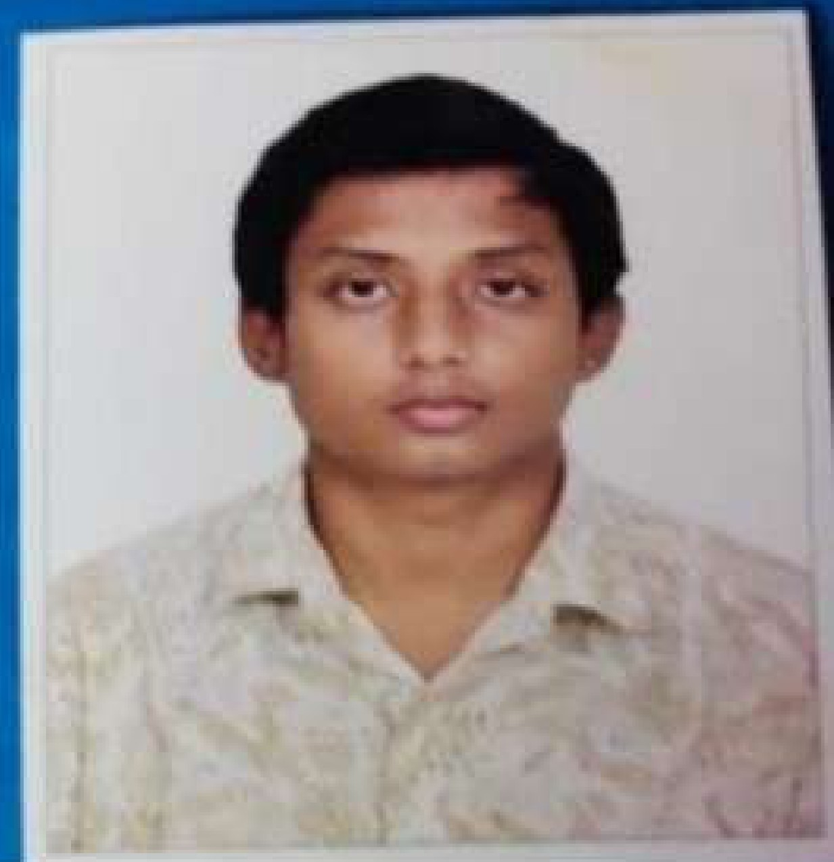

**KISHORE S**

**C13 TN HB COLONY VILLAPURAM,**

**MADURAI-11– 625012.**

**8870788100 | kishoreselvamak@gmail.com.**

**SUMMARY**

**EDUCATION DETAILS**

* To secure a challenging position in a reputable organization to expand my leanings, knowledge, and skills.
* Secure a responsible career opportunity to fully utilize my training and skills, while making a significant contribution to the success of the company.

**Sri Ramachandra Institute of Higher Education and Research** 2022

M.sc – Biotechnology pursuing 4thsem

7.4 CGPA (till now)

**SASTRA University**  2019

B.sc -Biochemistry with DMLT 5.62(CGPA)

**CEOA Matriculation Higher Secondary School** 2016

HSSC 61.5%

**AKKV Matriculation Higher Secondary School** 2014

87.02%

**SKILLS**

* MS Office Packages
* Bioinformatics.

**TRAINING**

**LANGUAGE**

**AROGYA Hospital at Madurai** 20 days

DMLT Training

**MEENAKSHI MISSION Hospital at Madurai** 20 days

DMLT Training

* Tamil
* English

**PROFESSIONAL STRENGTH**

**CONFERENCE AND SEMINAR ATTENDED**

* Self-confident,
* Time management,
* Team working,
* Adaptable,
* Responsible.
  + - International Virtual Conference on Current trends in Agricultural Biotechnology” Nov 30th – Dec 1st 2020, Sathyabama institute of science and Technology.

**PROJECT**

**WET LAB SKILLS**

* Screening of antimicrobial peptides from bacillus spp and its activity against multidrug resistant Escherichia coli.
* Molecular characterization of drug resistant E. coli and its inhibition using lipopeptides production bacillus spp. Whole genome short gun sequencing submitted to pubmed nucleotide database ( https://www.ncbi .nlm.nih.gov/ nuccore/ JANIJT000000000 ).
* PCR, Blotting techniques,
* Electrophoresis, DNA Isolation, streaking.
* Microscopic Techniques.
* Biochemical Characterization.

**EXTRA -CURRICULAR ACTIVITIES**

* Chess, Shuttle Cork and Cricket

**PERSONAL DETAILS**

**HOBBIES**

* Gardening and Listening songs

Father's Name : Selvam A

Date of Birth : 03/04/1998

Marital Status : Single

Nationality : Indian

**CERTIFICATION**

**Kishore S**

* **Forest and their managements** Issued by isser pune by NPTEL Swayam